**DESIGN RC PHASE SHIFT AND WEIN BRIDGE OSCILLATOR**

**Exp No: 6 Date: 3/03/2022**

**Objective:**

**To design, simulate and verify RC Phase Shift and Wein Bridge Oscillator and Band Pass.**

**Software Required:**

LT SPICE - XVII

**Theory:**

**RC Phase Shift:**

RC phase-shift oscillators use resistor-capacitor (RC) network (Figure 1) to provide the phase-shift required by the feedback signal. They have excellent frequency stability and can yield a pure sine wave for a wide range of loads.  
  
Ideally a simple RC network is expected to have an output which leads the input by 90o.

However, in reality, the phase-difference will be less than this as the [capacitor](https://www.electrical4u.com/working-principle-of-a-capacitor/) used in the circuit cannot be ideal. Mathematically the phase angle of the RC network.

Where, XC = 1/(2πfC) is the reactance of the capacitor C and R is the [resistor](https://www.electrical4u.com/what-is-resistor/). In [oscillators](https://www.electrical4u.com/what-is-an-oscillator/), these kind of RC phase-shift networks, each offering a definite phase-shift can be cascaded so as to satisfy the phase-shift condition led by the Barkhausen Criterion. One such example is the case in which **RC phase-shift oscillator** is formed by cascading three RC phase-shift networks, each offering a phase-shift of 60o.

Here the collector resistor RC limits the collector [current](https://www.electrical4u.com/electric-current-and-theory-of-electricity/) of the [transistor](https://www.electrical4u.com/bipolar-junction-transistor-or-bjt-n-p-n-or-p-n-p-transistor/), resistors R1 and R (nearest to the transistor) form the [voltage divider](https://www.electrical4u.com/voltage-divider/) network while the emitter resistor RE improves the stability. Next, the [capacitors](https://www.electrical4u.com/working-principle-of-a-capacitor/) CE and Co are the emitter by-pass capacitor and the output DC decoupling capacitor, respectively. Further, the circuit also shows three RC networks employed in the feedback path.

This arrangement causes the output waveform to shift by 180o during its course of travel from output terminal to the base of the transistor. Next, this signal will be shifted again by 180o by the transistor in the circuit due to the fact that the phase-difference between the input and the output will be 180o in the case of common emitter configuration. This makes the net phase-difference to be 360o, satisfying the phase-difference condition.

One more way of satisfying the phase-difference condition is to use four RC networks, each offering a phase-shift of 45o. Hence it can be concluded that the RC phase-shift oscillators can be designed in many ways as the number of RC networks in them is not fixed. However, it is to be noted that, although an increase in the number of stages increases the frequency stability of the circuit, it also adversely affects the output frequency of the oscillator due to the loading effect.

Where, N is the number of RC stages formed by the [resistors](https://www.electrical4u.com/types-of-resistor/) R and the capacitors C. Further, as is the case for most type of oscillators, even the RC phase-shift oscillators can be designed using an Opamp as its part of the amplifier section (Figure 3). Nevertheless, the mode of working remains the same while it is to be noted that, here, the required phase-shift of 360o is offered collectively by the RC phase-shift networks and the [Op-Amp](https://www.electrical4u.com/op-amp-working-principle-of-op-amp/) working in inverted configuration.

Further, it is to be noted that the frequency of the RC phase-shift oscillators can be varied by changing either the resistors or the [capacitors](https://www.electrical4u.com/working-principle-of-a-capacitor/). However, in general, the [resistors](https://www.electrical4u.com/types-of-resistor/) are kept constant while the capacitors are gang-tuned. Next, by comparing the RC phase-shift oscillators with LC oscillators, one can note that, the former uses a greater number of circuit components than the latter one. Thus, the output frequency produced from the RC oscillators can deviate much from the calculated value rather than in the case of LC oscillators. Nevertheless, they are used as local oscillators for synchronous receivers, musical instruments and as low and/or audio-frequency generators.

**What is a Wien Bridge Oscillator?**

A Wien-Bridge Oscillator is a type of [phase-shift oscillator](https://www.electrical4u.com/rc-phase-shift-oscillator/) which is based upon a Wien-Bridge network (Figure 1a) comprising of four arms connected in a bridge fashion. Here two arms are purely resistive while the other two arms are a combination of [resistors](https://www.electrical4u.com/what-is-resistor/) and [capacitors](https://www.electrical4u.com/working-principle-of-a-capacitor/).

In particular, one arm has resistor and capacitor connected in series (R1 and C1) while the other has them in parallel (R2 and C2).

This indicates that these two arms of the network behave identical to that of [high pass filter](https://www.electrical4u.com/high-pass-filter/) or [low pass filter,](https://www.electrical4u.com/active-low-pass-filter/) mimicking the behaviour of the circuit.

In this circuit, at high frequencies, the reactance of the capacitors C1 and C2 will be much less due to which the [voltage](https://www.electrical4u.com/voltage-or-electric-potential-difference/) V0 will become zero as R2 will be shorted.

Next, at low frequencies, the reactance of the capacitors C1 and C2 will become very high.

However even in this case, the output voltage V0 will remain at zero only, as the capacitor C1 would be acting as an open circuit.

This kind of behaviour exhibited by the Wien-Bridge network makes it a lead-lag circuit in the case of low and high frequencies, respectively.

**Wien Bridge Oscillator Frequency Calculation: -**

Nevertheless, amidst these two high and low frequencies, there exists a particular frequency at which the values of the [resistance](https://www.electrical4u.com/what-is-electrical-resistance/) and the capacitive reactance will become equal to each other, producing the maximum output voltage.

This frequency is referred to as resonant frequency. The resonant frequency for a Wein Bridge Oscillator is calculated using the following formula:

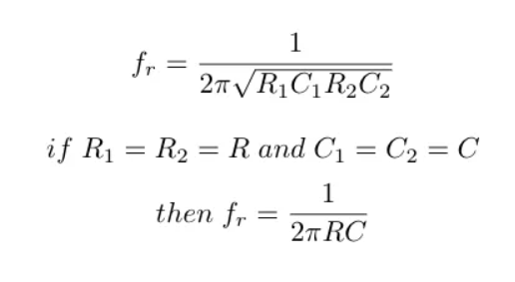

Further, at this frequency, the phase-shift between the input and the output will become zero and the magnitude of the output voltage will become equal to one-third of the input value. In addition, it is seen that the Wien-Bridge will be balanced only at this particular frequency.

In the case of **Wien-Bridge oscillator**, the Wien-Bridge network of Figure 1 will be used in the feedback path as shown in Figure 2. The circuit diagram for a Wein Oscillator using a BJT ([Bipolar Junction Transistor](https://www.electrical4u.com/bipolar-junction-transistor-or-bjt-n-p-n-or-p-n-p-transistor/)): -

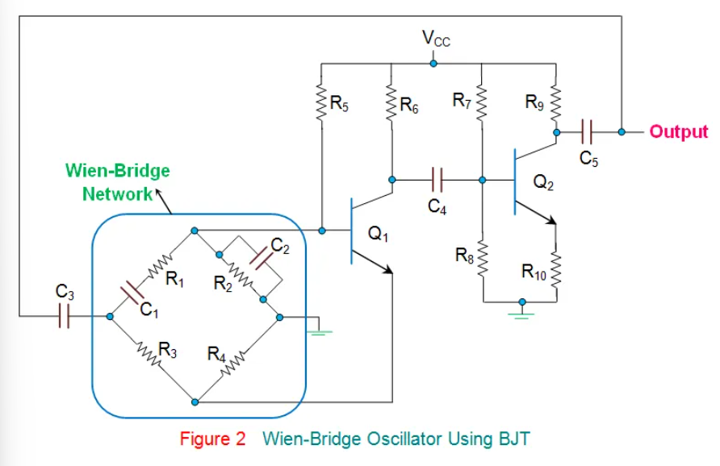

In these [oscillators](https://www.electrical4u.com/what-is-an-oscillator/), the amplifier section will comprise of two-stage amplifier formed by the [transistors](https://www.electrical4u.com/jfet-or-junction-field-effect-transistor/), Q1 and Q2, wherein the output of Q2 is back-fed as an input to Q1 via Wien-Bridge network.

Here, the noise inherent in the circuit will cause a change in the base [current](https://www.electrical4u.com/electric-current-and-theory-of-electricity/) of Q1 which will appear at its collector point after being amplified with a phase-shift of 180o.

This is fed as an input to Q2 via C4 and gets further amplified and appears with an additional phase-shift of 180o.

This makes the net phase-difference of the signal fed back to the Wien-Bridge network to be 360o, satisfying phase-shift criterion to obtain sustained oscillations.

However, this condition will be satisfied only in the case of resonant frequency, due to which the Wien-Bridge oscillators will be highly selective in terms of frequency, leading to a

frequency-stabilized design.

Wien-bridge oscillators can even be designed using [Op-Amps](https://www.electrical4u.com/op-amp-working-principle-of-op-amp/) as a part of their amplifier section, as shown by Figure 3.

However, it is to be noted that, here, the Op-Amp is required to act as a non-inverting amplifier as the Wien-Bridge network offers zero phase-shift.

Further, from the circuit, it is evident that the output voltage is fed back to both inverting and non-inverting input terminals.

At resonant frequency, the voltages applied to the inverting and non-inverting terminals will be equal and in-phase with each other.

However, even here, the voltage gain of the amplifier needs to be greater than 3 to start oscillations and equal to 3 to sustain them. In general, these kinds of Op-Amp-based Wien Bridge Oscillators cannot operate above 1 MHz due to the limitations imposed on them by their open-loop gain.

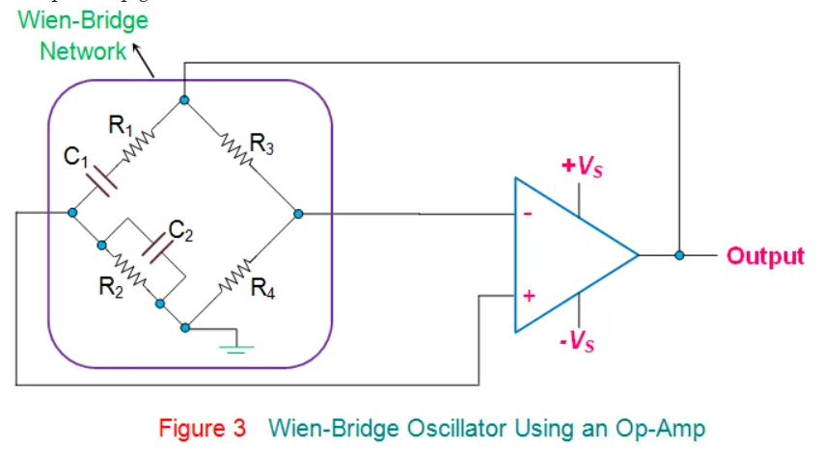

Wien-Bridge networks are low frequency oscillators which are used to generate audio and sub-audio frequencies ranging between 20 Hz to 20 KHz.

Further, they provide stabilized, low distorted sinusoidal output over a wide range of frequency which can be selected using decade resistance boxes.

In addition, the oscillation frequency in this kind of circuit can be varied quite easily as it just needs variation of the [capacitors](https://www.electrical4u.com/working-principle-of-a-capacitor/) C1 and C2.

However, these [oscillators](https://www.electrical4u.com/what-is-an-oscillator/) require large number of circuit components and can be operated upto a certain maximum frequency only.

**Procedure: -**

1. **Open LT Spice and click on new schematic to start the circuit making.**
2. **Components needed are: wires, ground, resistor, op-amp and voltage sources.**
3. **Place them all in the required way as per the requirement of circuit analysis.**
4. **Perform required analysis like transient or ac etc. (simulation commands)**
5. **Run the schematic once the circuit is complete**
6. **Click above the ac input voltage source for the input signal**
7. **Click above the load resistor to obtain the output signal.**
8. **Analyse the input and output obtained from the circuit analysis on LT Spice.**
9. **Save the schematic and continue further analysis if required.**

RC PHASE SHIFT: -

CIRCUIT: -

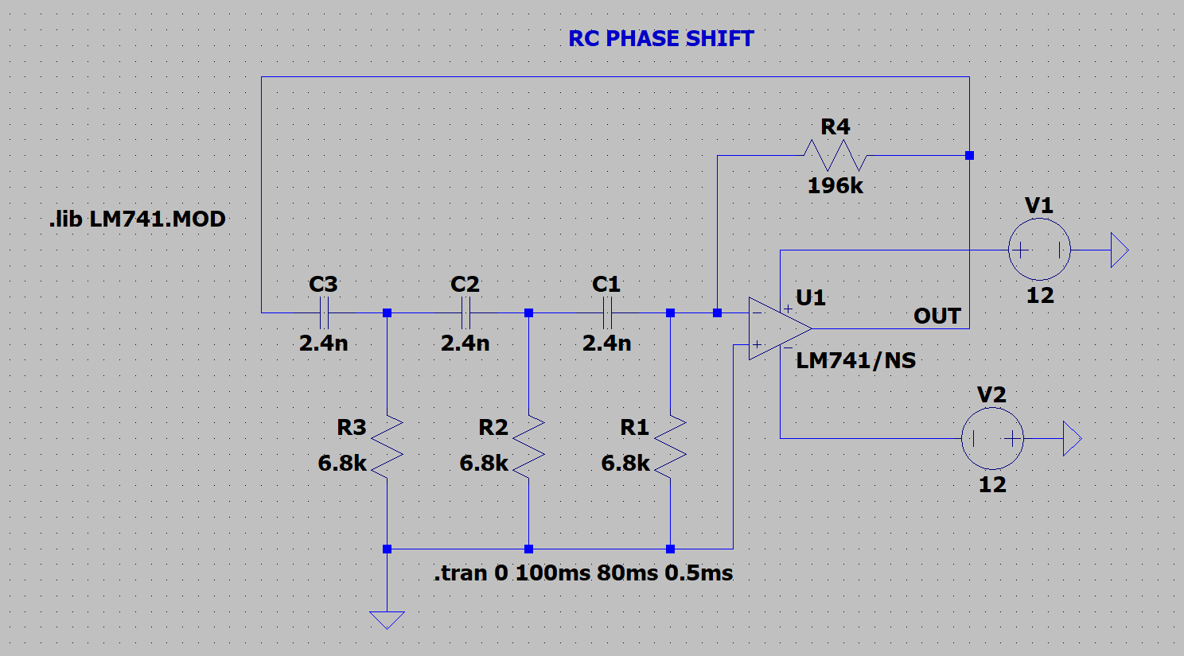

OUTPUT:

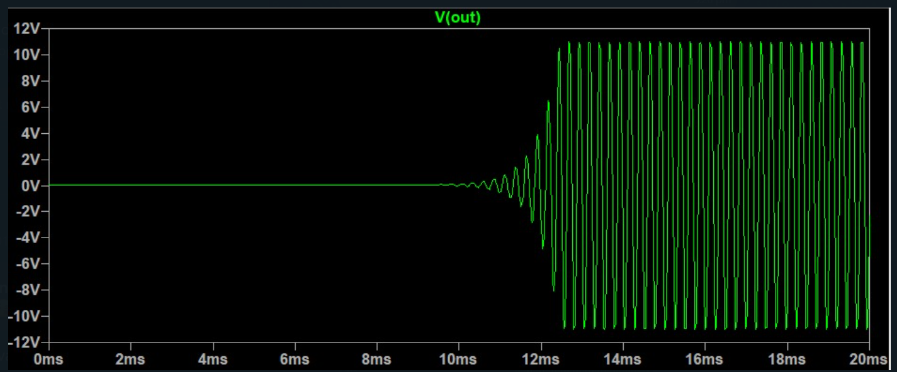

WEIN BRIDGE OSCILATOR: -

CIRCUIT:

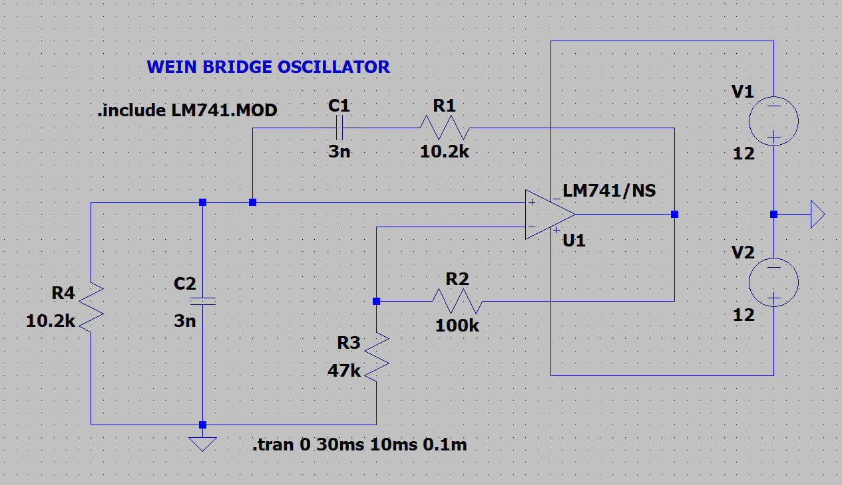

OUTPUT: -

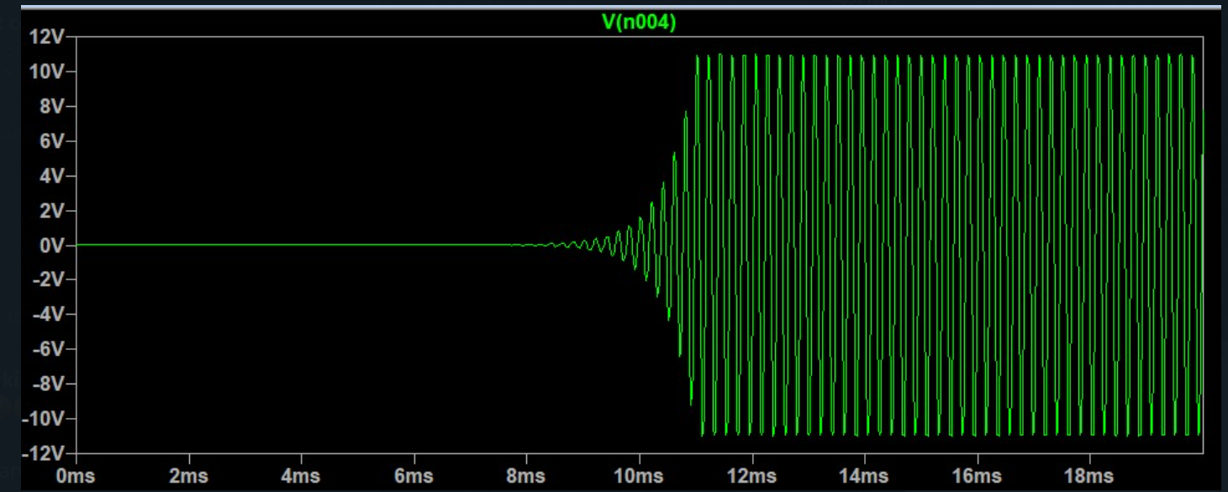

**RESULT: -**

**Thus, Wein bridge and RC- Phase Shift oscillator is designed, tested and verified using LTSPICE.**